Emotional Intelligence Work- Book (Level 3) Part 1
Introduction
This workbook was put together in using the reference of Emotional Intelligence 2.0 by Travis Bradberry and Jean Greaves. The book actually focuses on Self Awareness, Self – Management, Social Awareness, and Relationship Management. All four of these topics are important in mastering Emotional Intelligence overall. For the program OPTIMUM we a specifically focused on Self – Awareness and Self – Management. During this course we will also touch briefly on Body Language and the importance of it as it relates to sports.
To be socially present, you must be self - aware and remove distractions, especially the ones inside your head. First, we all have conversations and chatter going on inside our heads, we talk to ourselves constantly. We’re so busy having these internal chats that we tune the outside world out--- which is counterproductive to self-awareness. The second culprit is a process where we form our responses while the person we’re talking with is still in fact talking. This, too is counterproductive---it’s tough to listen to yourself and the coach/trainer fully. When you are in a conversation don’t interrupt the coach/trainer/person until he or she is completely finished. Next, to squelch the voice that is planning your response, it’s important to catch yourself in the act; and when you do, stop yourself and clear away the clutter.

Self – Awareness
To be self-aware is to know yourself as you really are. Getting know yourself inside and out is a continuous journey of peeling back the layers of the onion and becoming more and more comfortable with what is in the middle --- the true essence of you. You’re hard wired emotional reactions to anything come before you even have a chance to respond and it is important for you to see yourself as you really are. Since it isn’t possible to leave your emotions out of the equation, managing yourself and your relationships means you first need to be aware of the full range of your feelings, both positive and negative. When you don’t take time out to notice and understand your emotions, they have a strange way of resurfacing when you least expect or want them to. It’s their way of trying to bring something important to your attention. The emotions will continue to persist, and unnecessary damage will happen if you don’t began to control it. Facing the truth about yourself will always be hard and very unsettling as an athlete but having the ability to use your emotions to your advantage and the opponents disadvantage will always give you the edge you need in the clutch. On the next page we have an example of a ripple effect coming from a father.
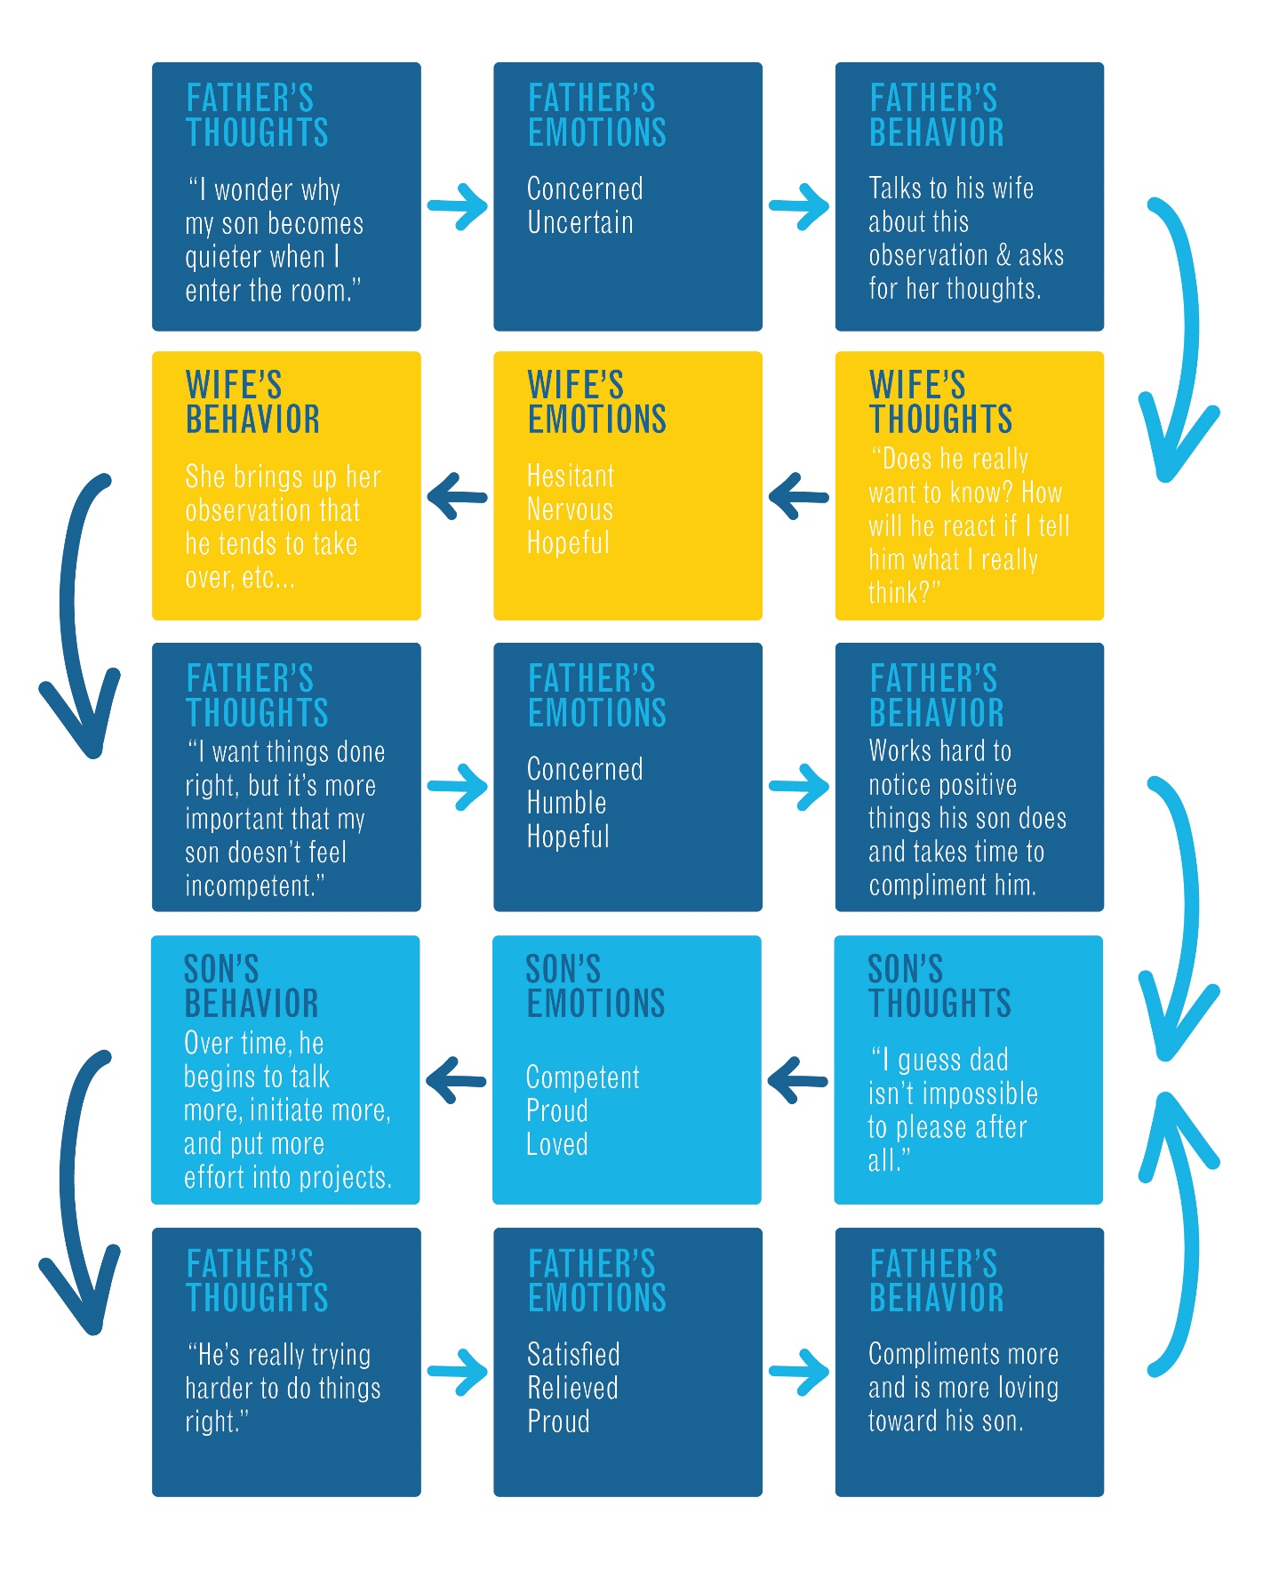
Feel your emotions physically
Knowing both who pushes your buttons and how they do it is critical to developing the ability to take control of these situations. Every time we get mad or upset us always have a specific feeling that comes along with it. If you can recognize the feelings that are associated with your emotions you can set up a game plan in order to not let it control you. Make a list of the people and things that push your buttons:
People Things

Now that you have recognized the things that bother you, over the next 7 days I want you to begin to recognize these emotions in the books that you read, the movies that you watch, and the music that you listen to. From this point on the books that you read, movies that you watch, and music that you listen to all have to put you in a positive mood, give you more confidence, or make you happy. If it doesn’t do these three things you shouldn’t engage in them.

Emotional Intelligence Journal (Self-Awareness)
Day 1
What put me in a bad mood today? Why?
__________________________________________________________________________________________________________________________________________________________________________________________________________________________________________

What put me in a good mood today? Why?
__________________________________________________________________________________________________________________________________________________________________________________________________________________________________________
Day 2
What put me in a bad mood today? Why?
__________________________________________________________________________________________________________________________________________________________________________________________________________________________________________

What put me in a good mood today? Why?
__________________________________________________________________________________________________________________________________________________________________________________________________________________________________________
Day 3
What put me in a bad mood today? Why?
__________________________________________________________________________________________________________________________________________________________________________________________________________________________________________

What put me in a good mood today? Why?
__________________________________________________________________________________________________________________________________________________________________________________________________________________________________________
Day 4
What put me in a bad mood today? Why?
__________________________________________________________________________________________________________________________________________________________________________________________________________________________________________

What put me in a good mood today? Why?
__________________________________________________________________________________________________________________________________________________________________________________________________________________________________________
Day 5
What put me in a bad mood today? Why?
__________________________________________________________________________________________________________________________________________________________________________________________________________________________________________
What put me in a good mood today? Why?
__________________________________________________________________________________________________________________________________________________________________________________________________________________________________________
Day 6
What put me in a bad mood today? Why?
__________________________________________________________________________________________________________________________________________________________________________________________________________________________________________
What put me in a good mood today? Why?
__________________________________________________________________________________________________________________________________________________________________________________________________________________________________________
Day 7
What put me in a bad mood today? Why?
__________________________________________________________________________________________________________________________________________________________________________________________________________________________________________
What put me in a good mood today? Why?
__________________________________________________________________________________________________________________________________________________________________________________________________________________________________________

You have four different types of responses to stress which you will learn on the next page. Describe yourself in detail when you are under any type of stress: Ex) When I am under pressure to pass a test I normally do better than when I don’t have any pressure on me at all.
______________________________________________________________________________________________________________________________________________________________________________________________________________________________________________________________________________________________________________________________________________________________________________________________________________________________________________________________________________________________________________________________________________________________________________________________________________________________________________________________________________________________________________________________
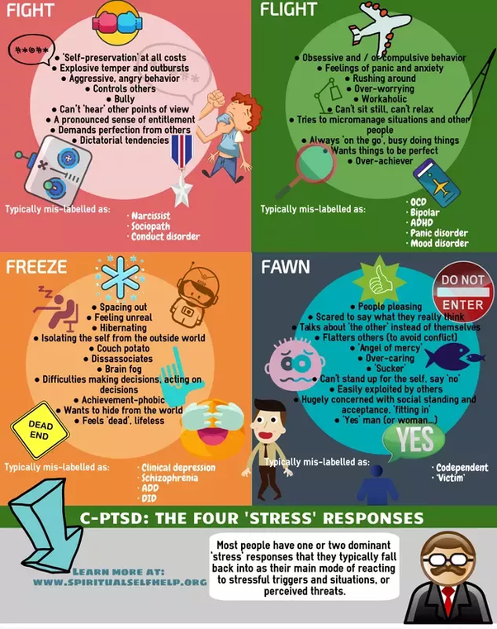

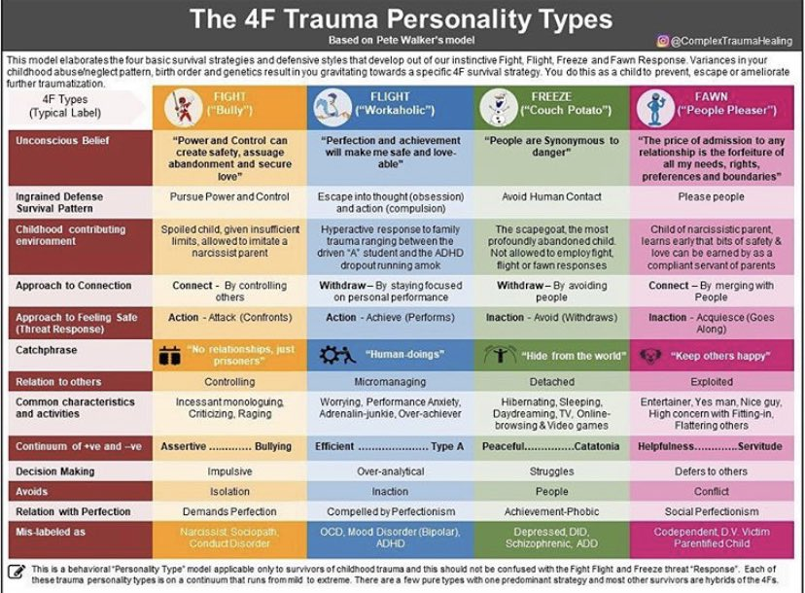

After looking at the 4 ways that people respond to pressure, which way do you respond to stress?
____________________________

We often mimic people that we like, but we also gravitate towards people who mirror us. Now that you know how you respond under stress please answer the question below:
Who are you consistently around that responds like this? _____________________________

Give an example of when this reaction happened to you below:
__________________________________________________________________________________________________________________________________________________________________________________________________________________________________________________________________________________________________________________________________________________________________________________________________________________________________________________________________________________________________________________________________________________________________________________________________________________________________________________________________________________________________________________________________________________________________________________________________________________________________________________________________________________________________________________________________________________________________________________________________________________________________________________________________________________________________________________________________________________________________________________________________________________________________________________________________________________________________________________________________________________________________________________________________________________________________________________________________________________________________________________________________________

How would you like to respond during stressful situations?
______________________________________________________________________________

What person that you are consistently around responds like this? _________________________

People who have success in self-awareness, also can master self-control and plan to avoid strong temptations because they know it will be tough for the to resist some urge after it has come. It is important that you beat the Akratic Action which is the failure of will or self-control. YOU ARE HUMAN so at times you will be tempted, so it is important to know that, recognize it, and be real about that. Overestimating your personal ability or skill mentally or physically can lead you to pursue goals that are beyond your ability and set you up for failure.
Self – Management
Most people’s weaknesses in emotional intelligence are simply the product of skills that come naturally to them. Due to this situation people who are gifted in the skills of emotional intelligence are normally easy to learn from. Learning from somebody is intentional, for this exercise you will choose a person that you feel like has a skill of self-management that you want to be your mentor. We prefer somebody older that you respect and are willing to listen to, so once you find that person please write their name below:

________________________________

Smiling and Laughing
Did you know that when you laugh and smile, your face sends signals to your brain that you are happy? Your brain responds to nerves and muscles in your face to determine your emotional state. When you feel yourself getting frustrated or distressing thoughts, force yourself to smile in order to counteract the negative energy that is developing. For this next activity we will have a smile counter. You will count how many times you smiled each day for the next seven days.

Day 1 Day 2 Day 3 Day 4 Day 5 Day 6 Day 7
______ ______ ______ ______ ______ ______ ______

Describe one situation this week when you had to intentionally smile and change your energy.
____________________________________________________________________________________________________________________________________________________________________________________________________________________________________________________________________________________________________________________________________________________________________________________________________________________________________________________________________________________________________________________________________________________________________________________________________________________________________________________________________________________________________________________________________________________________________________________________________________
Self – Talk
We all have an inward voice that can affect our perception in how we view things. You can always over think things or under think things, the most important thing is having a balance and always thinking about the positive side of things and where you can improve. It is something called Kaizen which means continues improvement and when you have this mindset you are consistently critiquing yourself and looking for ways you can improve even when you are at the top of your game. Your self-talk can damage your ability for self-management when you don’t have the ability to control the negativity which will lead to self-defeat. The goal of self-talk is to win the battle of it each and every day and eventually become an expert at it. Not being able to control self-talk could send you into a downward emotional spiral that makes it difficult to believe that you can really get what you want from life. The most common types of negative self-talk that you have to defeat on a daily basis are as follows:
- Change I always or never into just this time or sometimes – It’s important that you don’t beat yourself up over one mistake. If you do this, it will cause you to make situations bigger than what they really need to be. I remember my sophomore year in high school I turned the ball over at the beginning of the game which lead to me having one of the worst games of my life. I felt like because I worked so hard on my game that I should play perfect all the time and not ever make a mistake but I was completely wrong. At the end of the game my coach sat me down and asked me a question: Why do you think you played so bad? My reply was I DON’T KNOW. The coach said it’s because you take mistakes to literal. I said I shouldn’t make because I work to hard. He said regardless of how hard you work you are still human, so when you make a mistake use it as an opportunity to learn instead of something you loosed. He said from here on out every time you make a mistake tell yourself I WILL GET IT BACK ON THE NEXT PLAY. As I begin to take this attitude on I noticed how I started scoring more points than I ever scored before in my life. To master self-talk you have to the ability for forget things real quick.
- Change judgmental statements I’m a dummy to I made a mistake – If you put a permanent thought on a particular action you leave no room for improvement. Everything that you say to yourself has to from an objective standpoint. I remember my freshmen year of college basketball I had a head coach that when you made a mistake he would say you’re so stupid. It even got to the point where I would make a mistake and then try to beat him to call me stupid so I wouldn’t have to hear him say it. After this happened for the first year of my college career I began to gain more confidence in my ability. I really couldn’t tell you what happened exactly but one day I made a mistake and he did what he normally does, I stopped him and said no I AM STUPID I just made a mistake. The coach had the funniest look on his face and after pausing for about three seconds he said you are correct. I was stunned because I had beaten the idea of me being stupid and I remembered what my coach told me in high school which I believed him more than I believed my college coach. Your mindset will developed from who you listen to the most.
- Accept accountability and don’t point the blame on any one else – Every time a situation happens you need to accept the idea that it’s not all your fault nor is it all anybody else’s fault either. When doing this it has to be a balance so although you don’t control what other people do, you do have an ability to help influence the outcome of a team’s result by maximizing the influence that you have. I remember my senior year of college I scored the most points in one season than I had ever scored in my life. I even surpassed what I did in high school. I went on to be second team all-conference and was even mentioned of being an All-American. I felt really accomplished at the time but as years went by and I began to understand the value of team I realized that although I did great individually I sucked as a consistent teammate. Our record my senior year was 10 – 22 and at the end of games I would be happy because I did well and although people would praise me individually my team would get zero respect. When I look back on things today if I had an opportunity to do that over again I would have done a better job of maximizing my influence. I was the hardest worker on the team and had the most respect from people for what I did on the court. I realized that your brain has a difficult time separating what you see with your eyes and what you visualize with your mind so you have to make sure that they are on one accord. I saw my team being successful but I consistently visualized only myself being successful and learned that the energy which is strongest is always the one that will win out.

Visualization
When we visualization we rehearse the situation over and over in our head until it becomes reality. To make this work the best you have to be in a room where you have no distractions and immerse yourself fully in the scenes you want to be successful at on a consistent bases playing out in your head. This next exercise is going to help you master that one situation that you struggle with from a mental standpoint.

Describe a situation when you are under pressure that you struggle with:
__________________________________________________________________________________________________________________________________________________________________________________________________________________________________________________________________________________________________________________________________________________________________________________________________________________________________________________________________________________________________________________________________________________________________________________________________________________________________________________________________________________________________________________________________________________________________________________________________________________________________________________________________________________________

Describe how you want to respond in a situation like this: You will close your eyes for two minutes a day and VISUALIZE yourself being successful at this.
______________________________________________________________________________________________________________________________________________________________________________________________________________________________________________________________________________________________________________________________________________________________________________________________________

Sleep Hygiene
The most important thing to maximizing your ability to reach your peak height and mental performance is making sure that you get the proper rest. Just like you get use to a routine schedule when going to school on a daily basis or working at a job, the same holds true to your sleep schedule. It is very important that you get a regular sleep schedule where you are consistently getting six to eight hours of sleep a night. When you do this, it allows you to maximize your performance both mentally and physically which is what you need to have for optimal performance. Anytime you perform an action that is inconsistent with what you believe you feel a discomfort known as cognitive dissonance.

The four things you want to make a routine of doing are as follows:
- Get twenty minutes of morning sunlight – This sets your inner clock and allows it to become easier to fall asleep at night.
- Turn off all electronic devices two hours before bed time – The light from the TV or gaming system tricks your body into thinking its day time and make it difficult to fall asleep.
- Keep your bed for sleeping – Avoid working or watching TV on your bed. If you save your bed strictly for sleep your body will respond positively to this and you will be able to go to sleep much quicker.
- Avoid caffeine, especially during the P.M. – Caffeine has a six-hour half-life and keeps you from falling asleep.

Now that you know this valuable information lets answer a few questions:

- How many hours do you expect to get of sleep per day? __________
- What will be your expected bed time per night? ____________
- How many times a week do you use energy drinks? ___________
(THE GOAL IS FOR THIS # TO BE ZERO)

Control
One of the best things to master for any human is Self- Control but the most important word in this is CONTROL. Everybody wants to be in control of self and something around them. This next exercise you will make a list of everything that you can control and from here on out if you can’t control it you don’t need to waste energy on it. List all the things that you can control: Example) Grades, Attitude etc….
__________________________________________________________________________________________________________________________________________________________________________________________________________________________________________________________________________________________________________________________________________________________________________________________________________________________________________________________________________________________________________________________________________________________________
Life Lessons
As we have discussed previously in above activities having the Kaizen attitude where you continuously improve is the right mentally to have. It allows you to continue to get better in whatever it is that you are pursuing on a daily basis and not become stagnant which is what most people eventually end up doing. The other way for you to continue to learn things is to try to learn something new from anybody you encounter. As human beings we are all different creatures and come from many different walks of life. Everybody that you come in contact with you should try to learn from and even if it is something you perceive as negative it should be used in a positive manor. The goal for this next exercise is to learn three new things a day for the next seven days.
Day 1
What did you learn? From Who___________________
__________________________________________________________________________________________________________________________________________________________________________________________________________________________________________
Day 2
What did you learn? From Who___________________
__________________________________________________________________________________________________________________________________________________________________________________________________________________________________________
Day 3
What did you learn? From Who___________________
__________________________________________________________________________________________________________________________________________________________________________________________________________________________________________
Day 4
What did you learn? From Who___________________
__________________________________________________________________________________________________________________________________________________________________________________________________________________________________________
Day 5
What did you learn? From Who___________________
__________________________________________________________________________________________________________________________________________________________________________________________________________________________________________
Day 6
What did you learn? From Who___________________
__________________________________________________________________________________________________________________________________________________________________________________________________________________________________________

Day 7
What did you learn? From Who___________________
__________________________________________________________________________________________________________________________________________________________________________________________________________________________________________
Mental Recharge
Throughout the day our minds are constantly going thinking, dreaming, decision making and problem solving various things throughout. In order to protect that you have to have a list of activities that allows you to be able to relax and chill. The activities have to be something that doesn’t compromise your positive mindset or health. Example) Overeating is not a mental recharge. Playing video games can be. This needs to be something you do on a daily basis in order to help you allow your mind to rest. List 5 activities that will be used as a mental recharge for you. You will only do one of these per day:
1._______________________________________
2. ______________________________________
3._______________________________________
4._______________________________________
5._______________________________________

